## 

**Final Year Project Report**

**Online Voting System Using Face Recognition**



**Project Advisor:**

**Dr. Kashif Ishaq**

**Submitted By:**

|  |  |
| --- | --- |
| **Name** | **ID** |
| **Muhammad Tazeem Sajid** | **F2019065042** |
| **Ghulam Mustafa** | **F2019065103** |
| **Hamza Mudassar** | **S2020105012** |
| **Sohaib Naveed** | **F2019105094** |

**Session:**

**(2019 – 2023)**

**Department:**

**University of Management and Technology,**

**Department of Informatics and Technology**

**C-II Johar Town Lahore Pakistan**

**Dedication**

**Teacher:**

We dedicate it to our teachers and mentor whose direction and knowledge helped us to shape this project and make us a better student. We appreciate your tolerance and work.

**Parents:**

To our parents, who have unwavering support throughout this journey. Your belief in us have fueled our determination to complete this project successfully.

This project is dedicated to countless nights of hard work and persistence. It is a testament to the power of dedication and the reward that come from unwavering commitment. Specially the project is dedicated to future students who will build upon this work, may this project be stepping stone for further advancement and discoveries. May it spark curiosity and inspire future generation to peruse excellence.

**Final Approval**



**Acknowledgment**

I would like express my hearfelt gratitude to Allah Almighty, the Most Merciful and the most Gracious, for granting us the strength, wisdom, and preserverance to complete our final year project successfully.We are truly humbled by his blessing and guidance throughout this journey.

Our supervisor **Dr.Kashif Ishaq** for their constant guidence, encourgment and valuable insighht. We are gratful for their experties and the opportunity to benefit from their wisdom.

Our special acknowledgement the faculty of IT Department at UMT for their commitment to education and their dedication to nurturing a culture of learning. We are thankful for their guidance and he knowledge we have gained through their teachings.

We were also like to express our appreciation to our friends and classmates who have supported us throughout this journey. Your companionship and encouragement have made this experience more fulfilling

Lastely, we were like to acknowledge the unwavering support of our family. Their love, prayers and belief in our abilites have been a constant source of strength. We are enternelly grateful to them for their encouragement and understandings.

**Project Title:** Online Voting System Using Face Recognition

**Objective:**

Online voting system Using Face recognation is a Web-based system through that we can cast vote thet use face recognition technology. This syteaim to provide a secure efficient and convenient method for conducting voting processess. This system can be used by different organizations or companies.

**Undertaken by:** Muhammad Tazeem Sajid (F2019065042)

Ghulam Mustafa (F2019065103)

Hamza Mudassir (S2020105012)

Sohaib Naveed (F201905094)

**Supervised by:** Dr.Kashif Ishaq

**Starting Date**  4 December 2023

**Completion Date**

**Tools Used Software:**

* + - * Front (React.js, HTML, CSS, JavaScript, Boot Strap)
      * Backend (Node.js, Laravel, PHP)
      * Database (MySQL)
      * Vs Code
      * XAMPP

**Operating System** Windows

**Documentation** MS Word

**Plagairism Report**

**Declaration Form**

After closely reviewing the documentation for the Final Year Project entitled "Online Voting system using face Recognition," I certify that it meets all requirements for a Final Year Project report at the undergraduate level.

The UMT Library's Turnitin program was used to check the work for plagiarism. The document's similarities are within an acceptable range.

Additionally, the source code, binaries with user manuals and installation guides, and a PDF version of the documentation are included on the accompanying CDs.

**Advisor Name: ______________________________**

Signature: __________________ Date: ___________________

**Abstract**

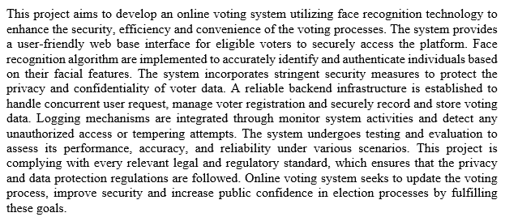

Revision Chart

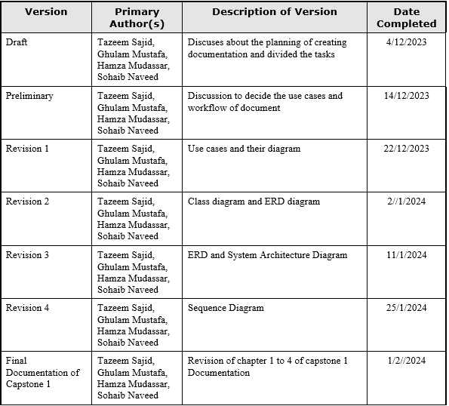

# Contents

Contents 1

Definitions and Acronyms 3

List of Figures 4

List of Tables 5

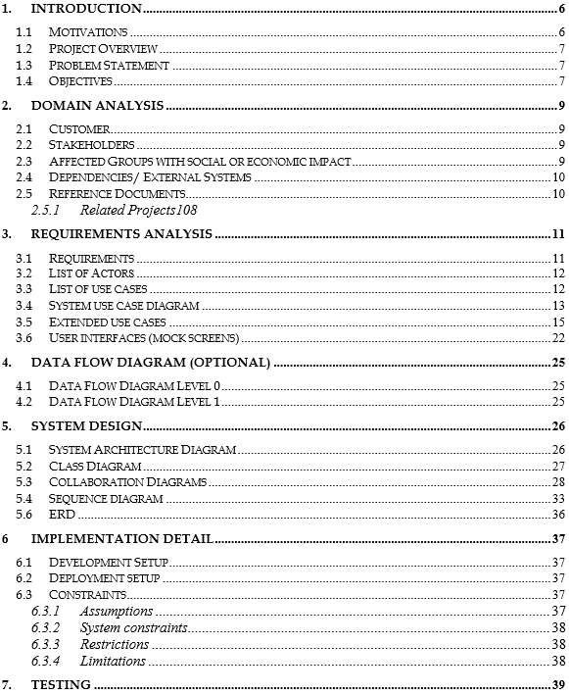

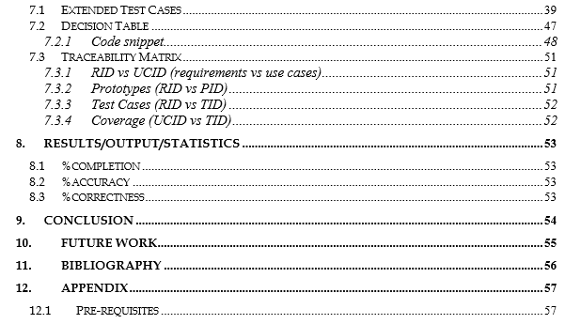

## Definitions and Acronyms

Table 1: Acronyms and Definitions

## 

1. **List of Figures**

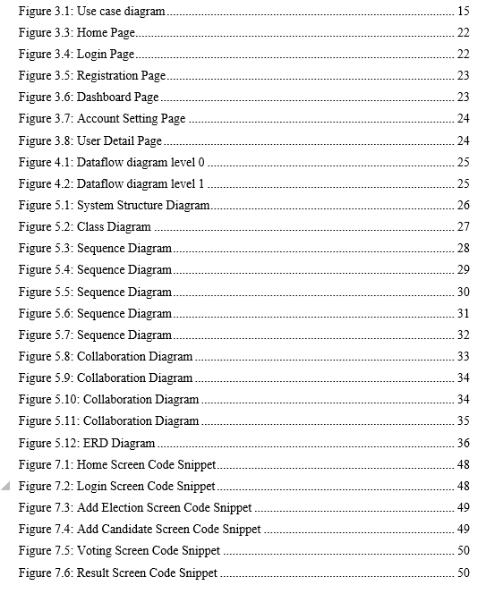

**2.**  **List of Tables:**

## 

# Introduction

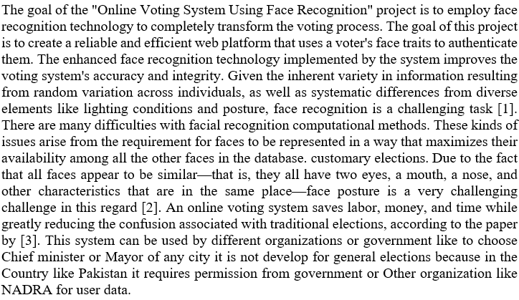

## Motivation

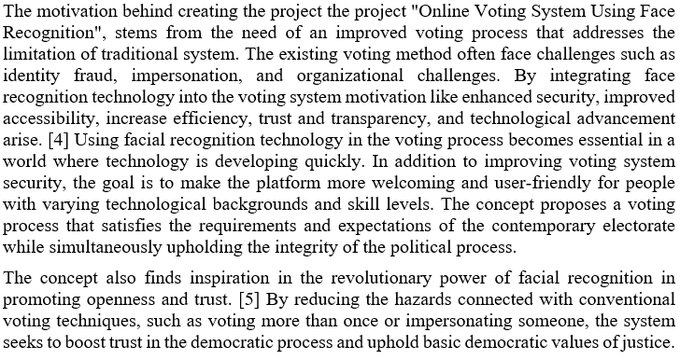

## Project Overview

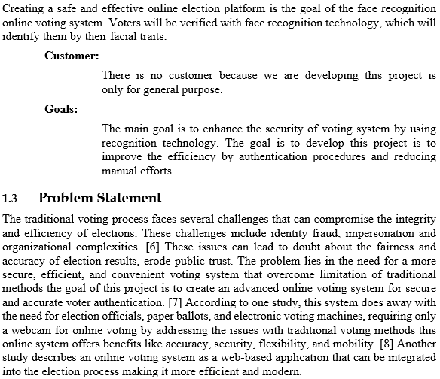

## Objectives

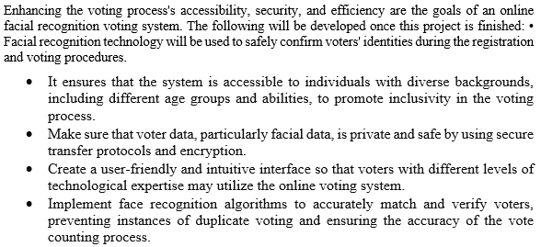

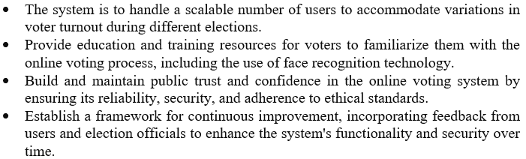

# Domain Analysis

## Customer

The primary customer of “Online Voting System Using Face Recognition” are the companies or different organizations who are interested to hold election in their company for any position.

## Stakeholders

Table 2.1: Stakeholder List

|  |  |
| --- | --- |
| **Primary Stakeholder** | **Role in System** |
| Voters | Voters are the primary user of online voting system who cast their vote by register them self through authentication their identity. |
| System Developers | The system developers are responsible for developing, designing, and implementing the online voting system. They work with the stakeholders to understand the requirements. |
| **Secondary Stakeholder** | **Role in System** |
| Technology Providers | Technology providers may be involved in supplying software, hardware or component required to develop a online voting system. |
| Election Observers | Election observer play a vital role in ensuring the transparency and fairness of elections. |
| Candidate | Candidate have a interest in the integrity and accuracy of the voting system. They rely on online voting system to provide fair and transparent result. |

## Affected Group with social or Economic Impact

**2.3.1 Voters**

* **Social Impact:** Enable candidate to participate from anywhere in the world with internet access.
* **Economic Impact:** Cost saving for voters by eliminating the need of travel to physical polling stations.

**2.3.2 Candidates**

* **Social Impact:** Candidates experience may increase trust and confidence in the electoral process
* **Economic Impact:** Candidates may benefit from cost saving associated with streamline voting process, as the online system eliminates the need of manual counting and potential counting.

**2.3.3 Technology providers**

* **Social Impact:** Contributing to the strengthening of voting process, and trust in technology enabled system.
* **Economic Impact:** Creating business opportunities and collaboration in the development, customization and secure online voting technology.

**2.3.4 System Developers**

* **Social Impact:** Contributing to the development and implementation of a secure, reliable and user-friendly online voting system.
* **Economic Impact:** Developer may benefit economically through involvement in the project. They gain expertise in developing online voting system and explore new business in the field of online voting technology.

## Dependencies/ External Systems

* Face Recognition software\Technology
* Database Management system
* Internet connectivity
* Hardware Component
* Security Infrastructure

## Reference Documents

Online voting system: A Review of existing system and Technology. - Research papers By John Doe and Jane Smith

Face recognition Technology: Principles, Method and Applications - Book by Mark Johnson

Technical specification for Face Recognition of Hardware and Software – Document By Face Tech Corporation.

### Related Projects

* Android Voting System Using Face Recognition – By Comsats University Students
* Smart Voting using Facial Recognition – By IJRASET
* Smart Voting Using Face Recognition based image processing _ By V

# Requirement Analysis

## Requirements

**Table 3.1: Functional requirements**

|  |  |  |
| --- | --- | --- |
| **#NO** | **Requirements** | **Description** |
| **FR1** | **Create Pool** | The system should enable administration create the pool of election. Pool help organize candidate and allowed voters to select their candidate with in designated pool. |
| **FR2** | **Delete Pool** | Admin Should have the capabilities to delete the pool if it is no longer required or relevant |
| **FR3** | **Update Pool** | Administration have the right to update the information such as pool name, description. |
| **FR4** | **Search Pool** | System provide the functionality to administration for search specific pool based on their information |
| **FR5** | **Cast vote** | User caste the vote according to their choice of candidate. |
| **FR6** | **Generate Result** | System should allow the admin to generate and see the report or result of voting process to determine the winner. |
| **FR7** | **Registration** | Voter register ir self by giving username, id card number their picture and phone number. |
| **FR8** | **Login** | User and admin first signup to the system and then login by providing their information like username/Emil and password |
| **FR9** | **Recover Password** | Voter and admin have the functionality provided by system to recover their password if they have forgot it |
| **FR10** | **Feedback** | User give feedback about the system and the voting process |

**Table 3.2: Non-Functional requirements**

|  |  |  |
| --- | --- | --- |
| **#No** | **Requirements** | **Description** |
| **NFR1** | **Accuracy of Face Recognition** | The face recognition algorithm has a high accuracy rate to ensure reliable voter authentication. It refuse the unauthorized access for casting vote. |
| **NFR2** | **Security** | The system should comply robust security measure to protect user data, prevent unauthorized access and insure ballot integrity |
| **NFR3** | **Performance** | The system should handle the high volume of concurrent user during voting period that not decrease the performance of the system. Response time should be fast and efficient. |
| **NFR4** | **Scalability** | The system should be scalable if an increasing number of voters without compromising performance. It should handle the growing database load. |
| **NFR5** | **Reliability** | The system should reliable and available for user to access and use during the voting period. It should handle system failures, data backup and disaster recovery |
| **NFR6** | **Compatibility and accessibility** | The system should be compatible with different web browser and accessible across different devices like mobile, tablet and desktops or laptop |

## List of Actors

* **Voter -** Eligible individual that participating in the voting process
* **Administrator -** Responsible for managing and overseeing the system.
* **System -** Represent the automated system that facilitates the online voting process

## List of use cases.

* **Register as Voter:** Allow the eligible user to create voter account by providing required information
* **Log_In:** User provide their credential and access the system.
* **Forget Password:** User recover their password when forget it.
* **Caste Vote:** Allow a register voter to select and cast their vote according to their choice.
* **Manage user Account:** Allow administrator to create, update and deactivate user account.
* **Create Pool:** Allow administrator to create pool for grouping candidate that are register for voting process
* **Delete Pool;** Allow administrator to delete pool if t is no longer required.
* **Generate Election Results:** Enable the administrator to view and generate election result based on the vote cast.

## System use case diagram

The voting system's admin-side UML use case diagram is described that admin registers or login into the system then create pool for election, Admin manage the pool all information and user account such as search, update, create and delete the pool or user account information in the system. After that admin view the election result and publish it to the voters as shown in figure 3.1

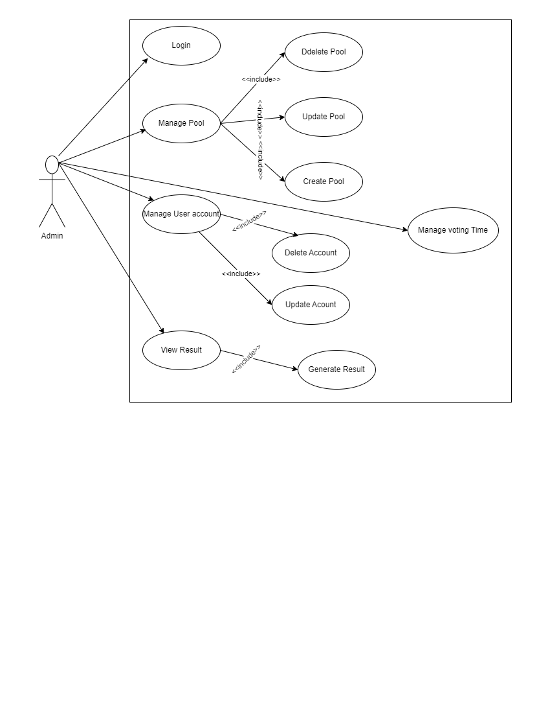**Figure 1: Admin Side Use Case**

The system use case describes the functionality of cast vote by the user and show the admin and system role in the process of voting. First user register and provide information then admin create pool for election that are visible to the user. After see the pool user cast their vote to their interest candidate and confirm their choice computer or system check the user using face features that user is eligible or not. After this system save the date and user choice. When voting process end the system count voting and admin view the result or show it to the voters by publishing it as shown in figure 2.

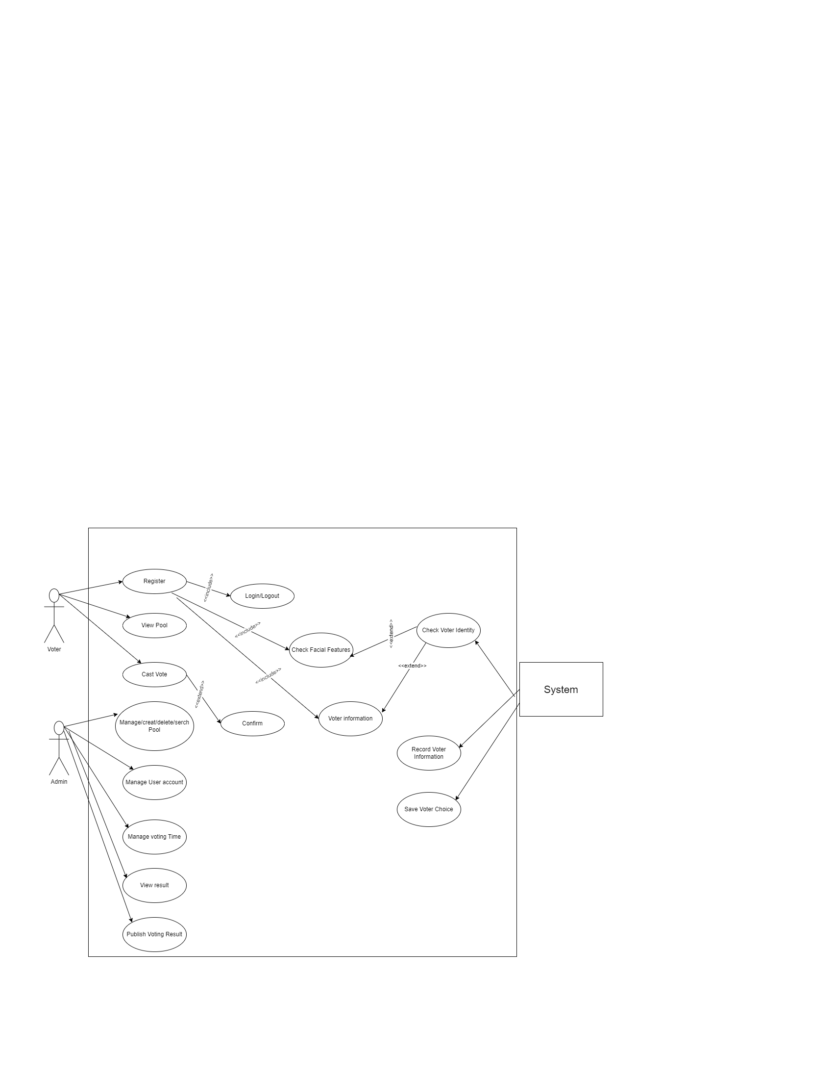

Figure 2: System use case

## Extend Use Cases

**Table 3.3: Registration Use Case**

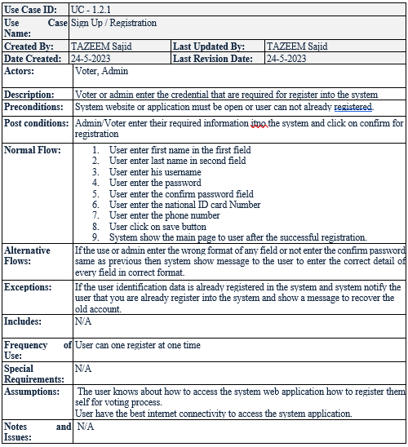

**Table 3.4: Login Use Case**

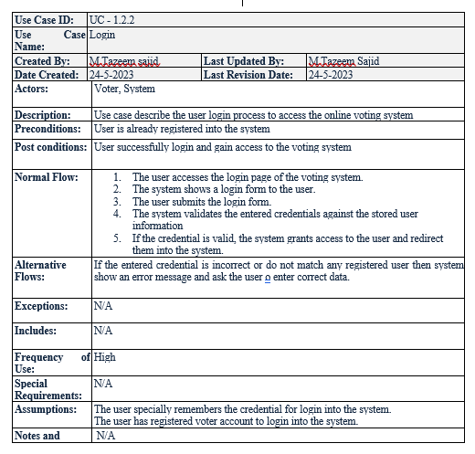

**Table 3.5: Change setting Use case**

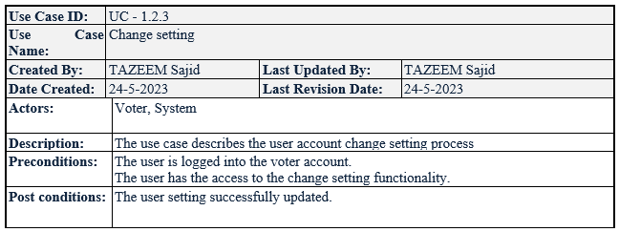

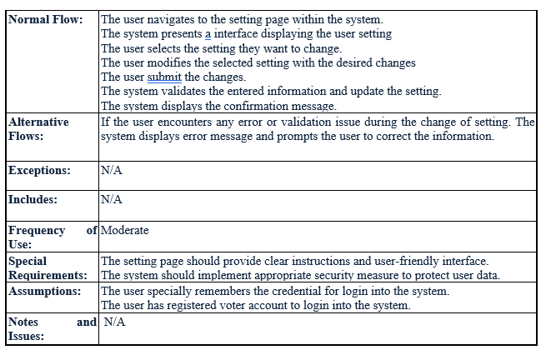

**Table 3.6: Recover Password Use case**

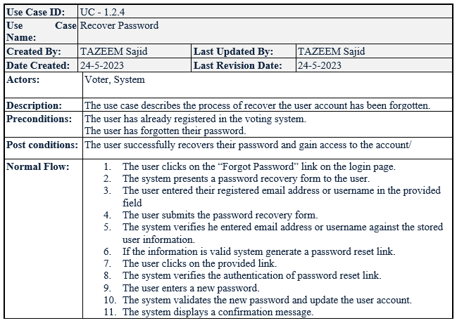

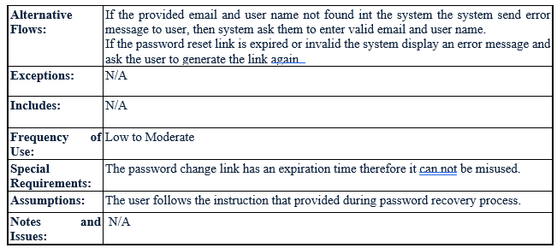

**Table 3.7: Create Pool Use case**

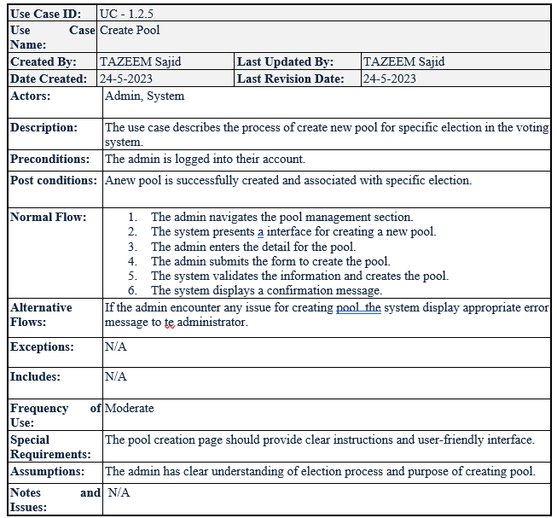

**Table 3.8: Update Pool Use case**

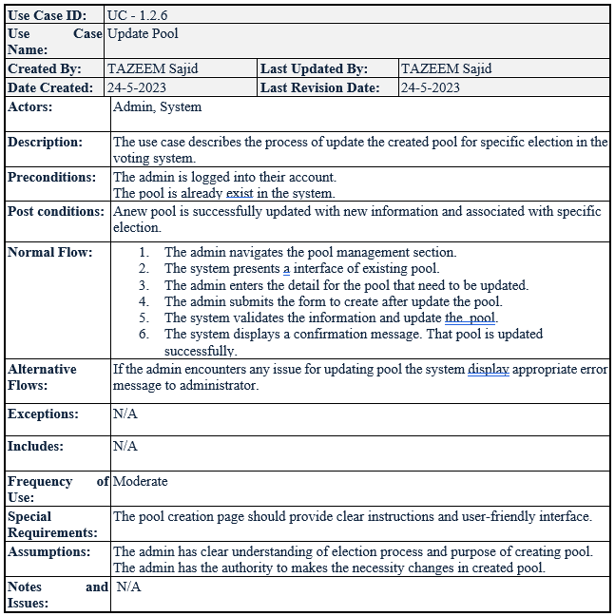

**Table 3.9: Delete Poll Use case**

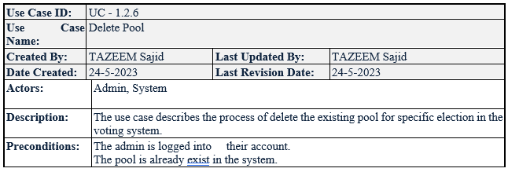

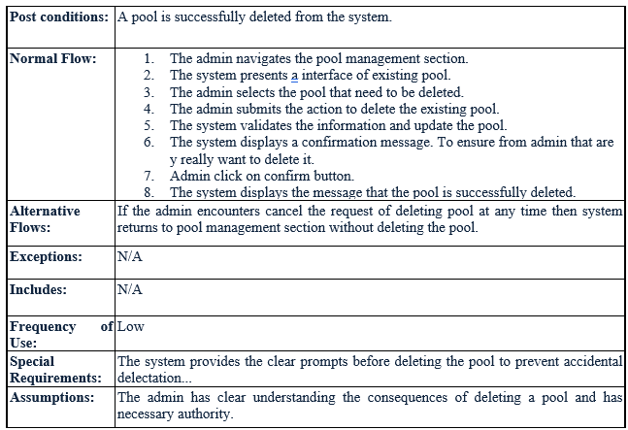

**Table 3.10: Caste Vote Use case**

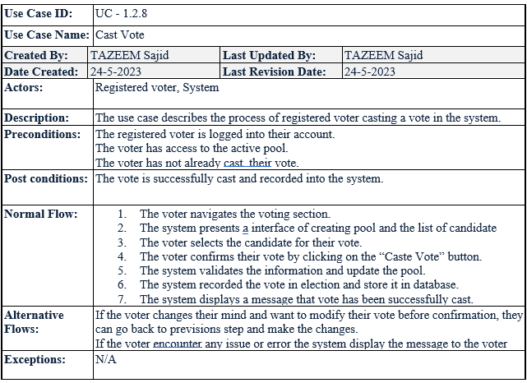

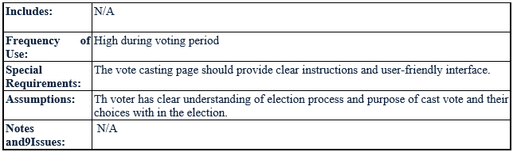

**Table 3.11: Generate Result Use case**

## 

## User interface (Mockup Screen)

Effortlessly navigate our user-friendly interface ensuring that voter can easily navigate through the platform without unnecessary distraction. A well-organized menu and straight forward navigation make it easy for the voter to find information they needed. The website provides straightforward and secure process for casting votes, with clear instructions at each step.

* + 1. **Home Page**



**Figure 3.3: Home Page**

**3.6.2 Login Page**

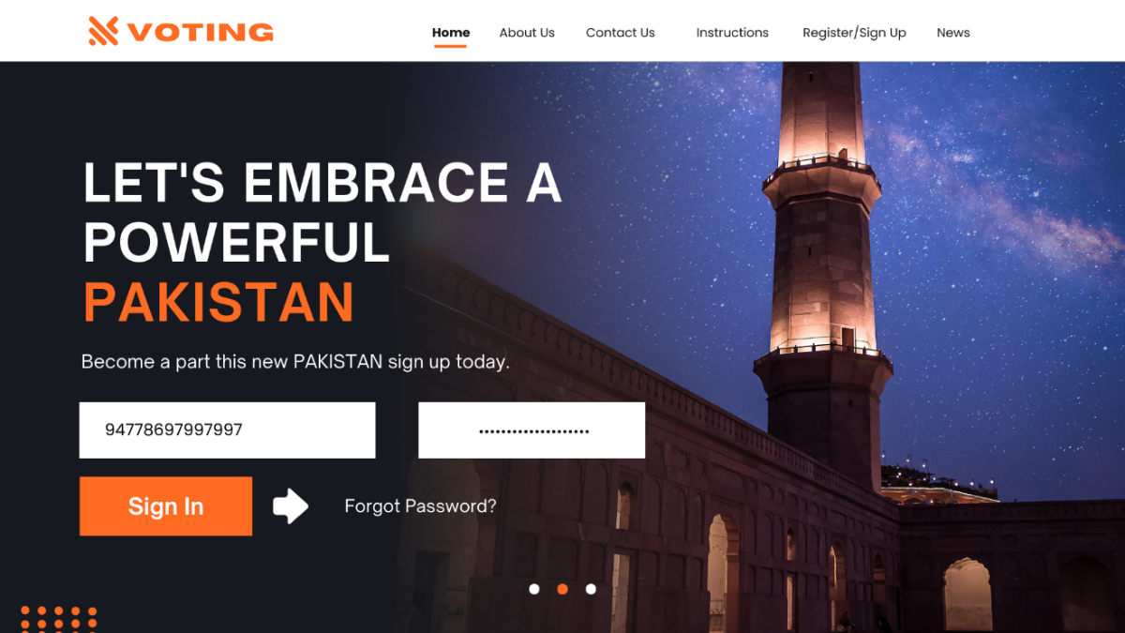

**Figure 3.4: Login Page**

**3.6.3 Registration Page**

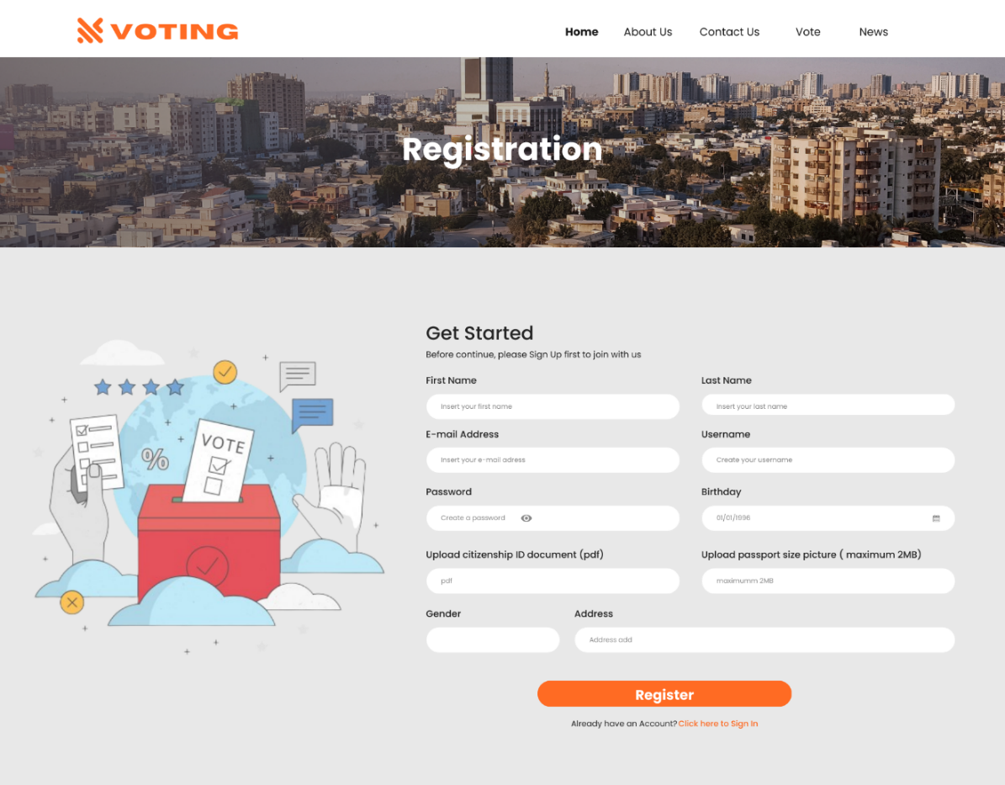

**Figure 3.5: Registration Page**

**3.6.4 Dashboard**

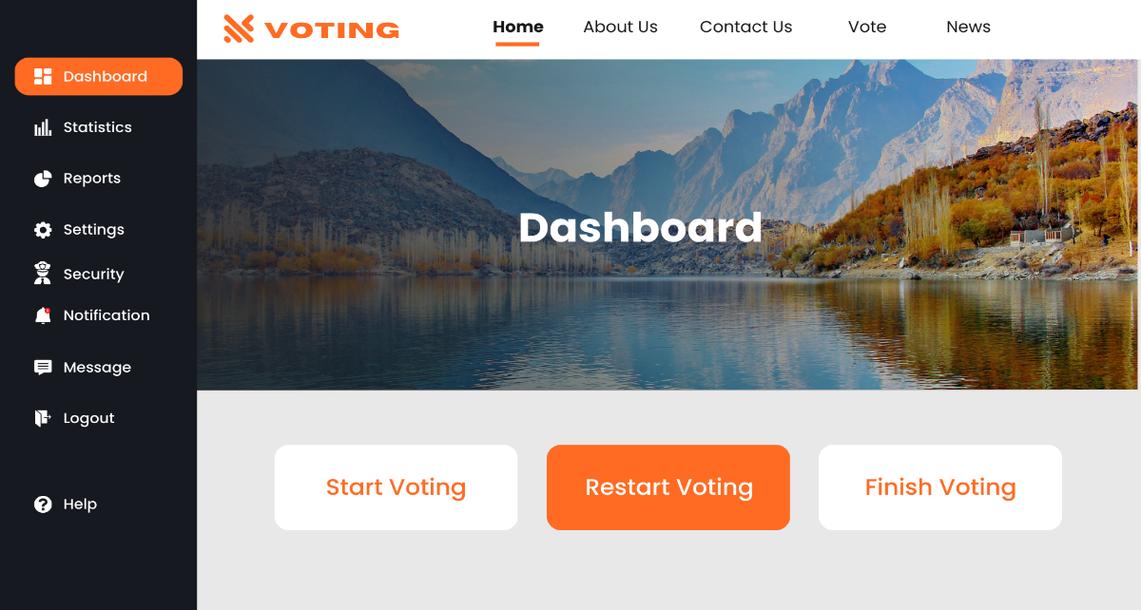

**Figure 3.6: Dashboard**

**3.6.5 Account Setting**

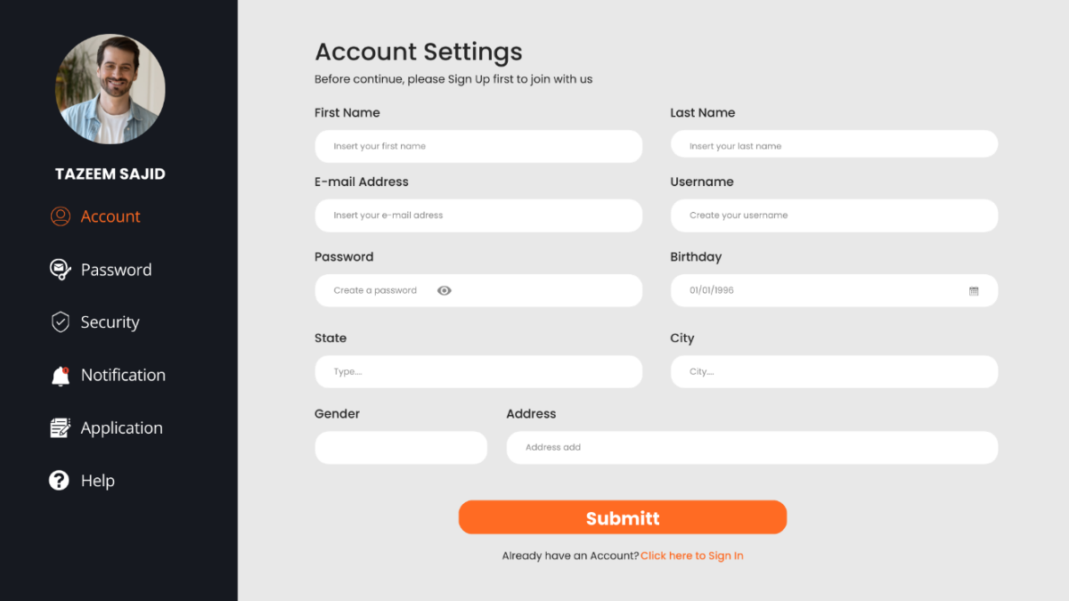

**Figure 3.7: Account Setting**

**3.6.5 User Detail**

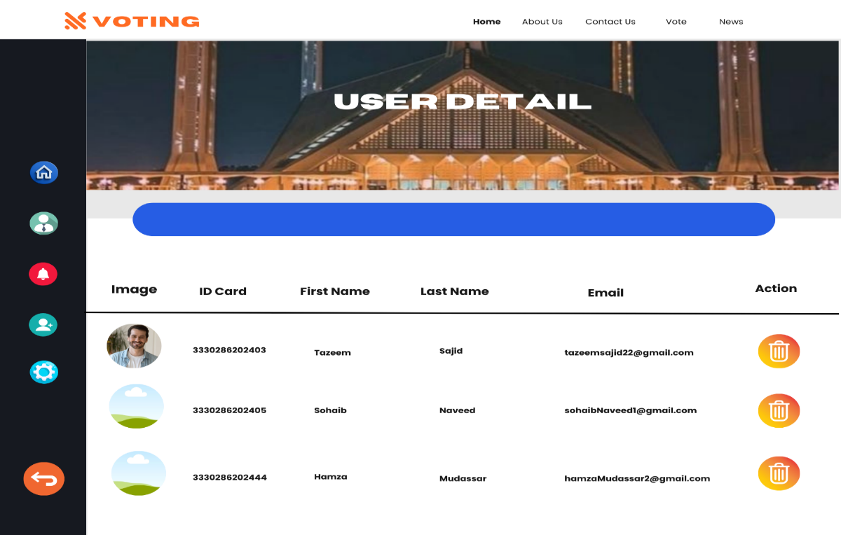

**Figure 3.8: User Detail**

# Data Flow Diagram

In Level 0 DFD diagram for “Online Voting system Using Face Recognition” illustrating the seamless flow of information among key processes, offer a comprehensive depiction of platform core functionalities at high level perspective.

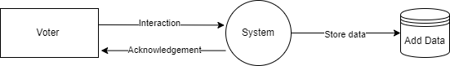

**Figure 4.1: Data flow diagram Level 0 (Voting system)**

**4.2 DFD Level_1**

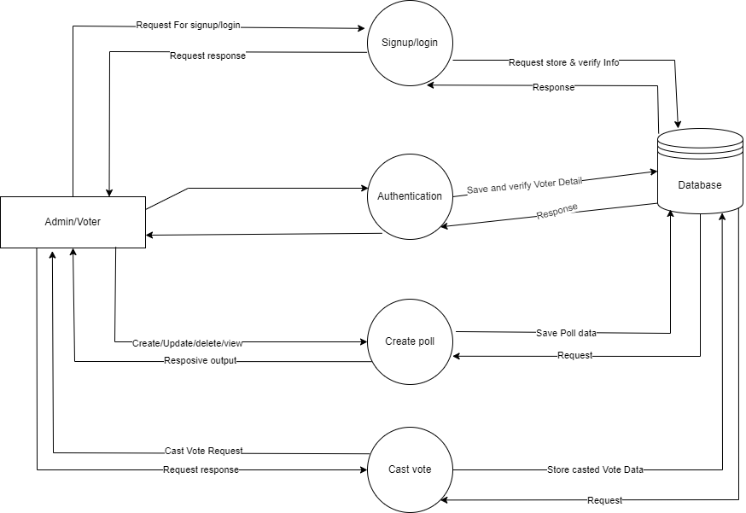

**Figure 4.2: DFD Level_1 (voting system)**

# System Design

## System Architecture Diagram

## Online Voting system securely designed, featuring a rubust three tire structure, ensuring scalability, with a presentation layer for user interface, app;ication layer handling voting process, and the data layer managing the storage and retravel of voting information as shown in figure 4.1.

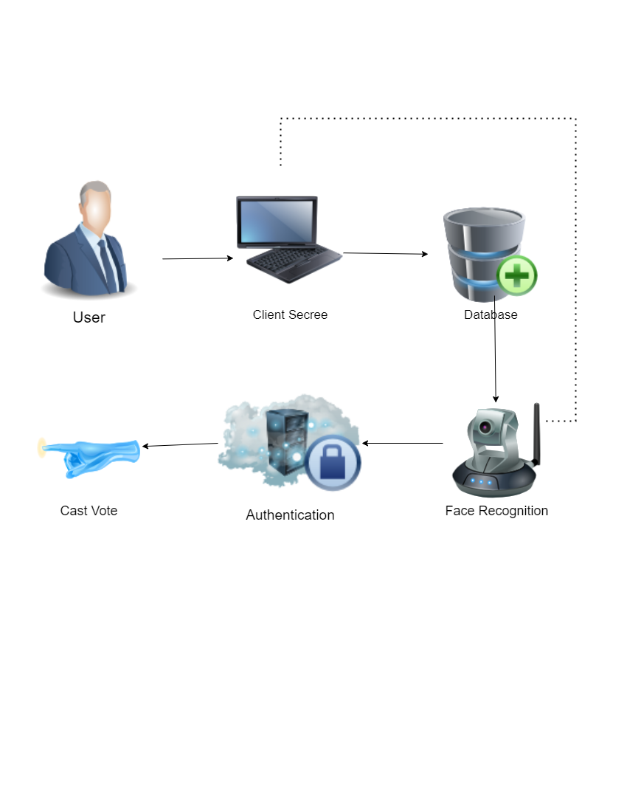

Figure 5.1: Architecture Diagram

## Class Diagram

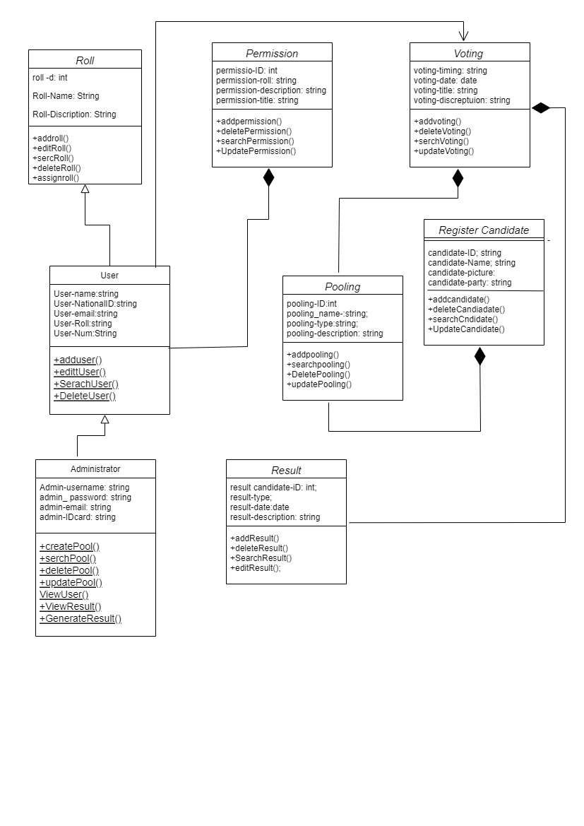

## Figure 5.2: Class Diagram

## Sequence Diagrams

5-step Sequence Diagram for “Online voting system Using Face Recognition” delineating the clear flow from registration to vote casting encapsulating the initiative process for user friendly experience.

* + 1. **Sequence Diagram 1: Login Page**

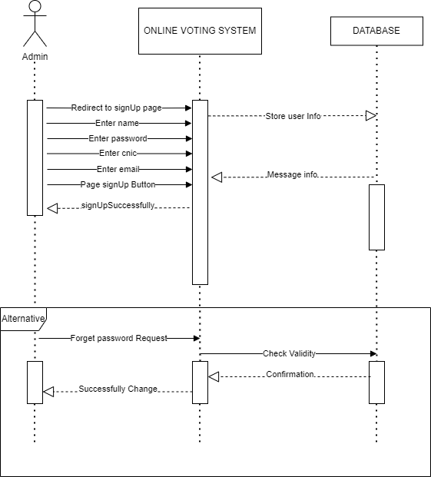

**Figure 5.3: Sequence Login Page Diagram**

* + 1. **Sequence Diagram 2: Admin Panel & Check Authentication**

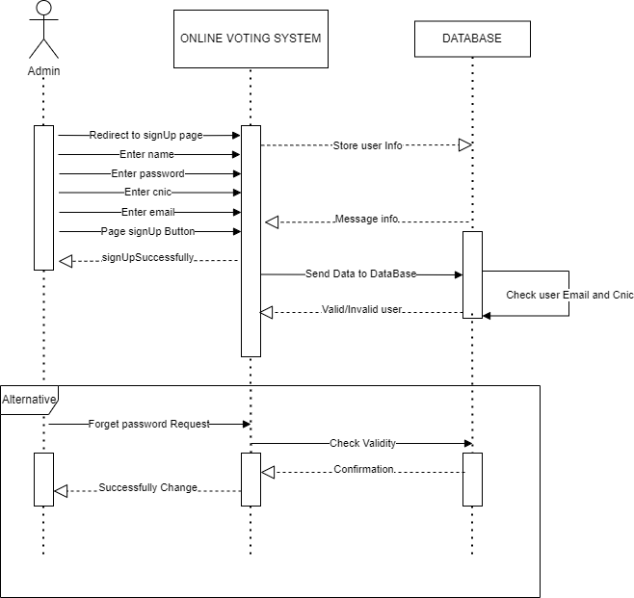

**Figure 5.4: Sequence Admin Panel Authentication Diagram**

* + 1. **Sequence Diagram 3: Create Voting Admin Panel**

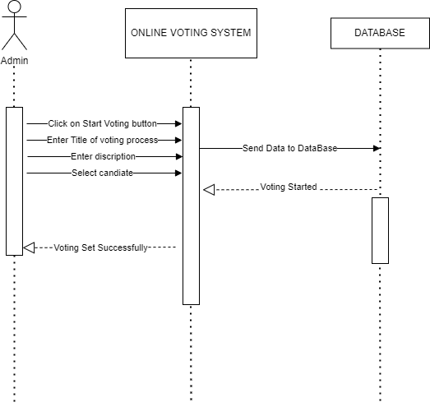

**Figure 5.5: Sequence Create Voting Diagram**

* + 1. **Sequence Diagram 4: Cast Voting**

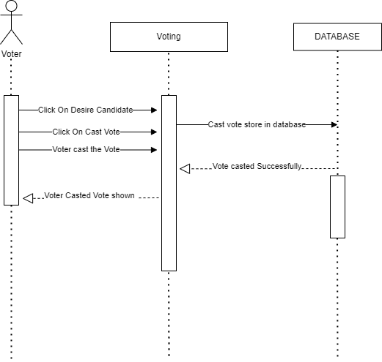

**Figure 5.6: Sequence Cast Voting diagram**

* + 1. **Sequence Diagram 5: System Sequence Diagram**

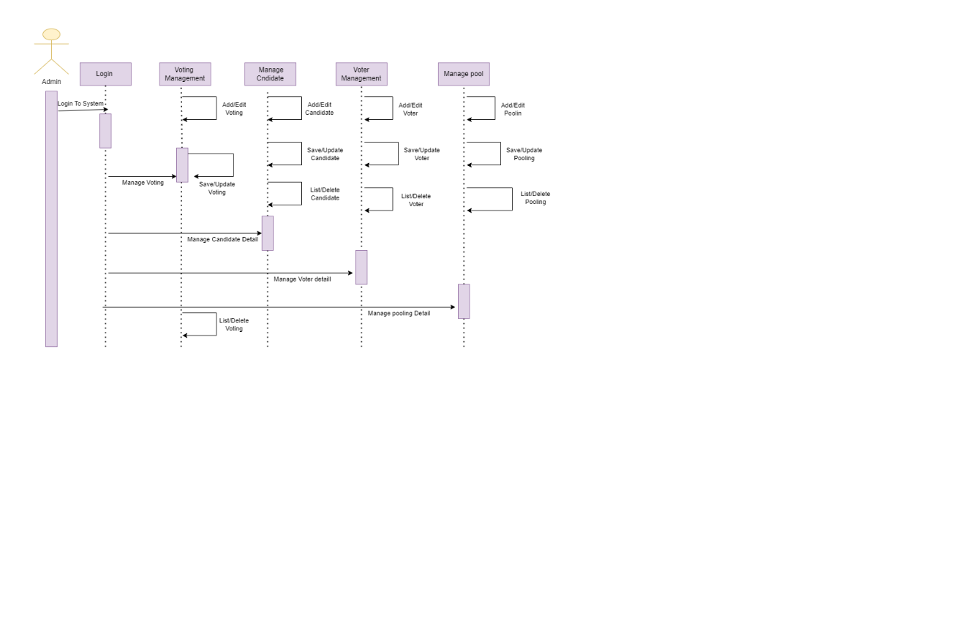

**Figure 5.7: System Sequence diagram**

## Collaboration Diagrams

The collaboration diagram for “Online voting system using face recognition” illustrates a harmonious synergy between user and the platform, showcasing a collaborative ecosystem where seamless interaction drive a thriving voting process.

**Collaboration Diagram 1: Signup Page**

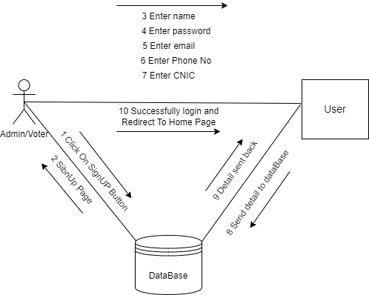

**Figure 5.8: Collaboration signup page Diagram**

* + 1. **Collaboration Diagram 2: login Page**

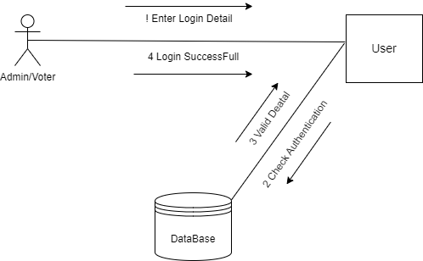

**Figure 5.9: Collaboration Login Page Diagram**

* + 1. **Collaboration Diagram 3; Create Voting Poll**

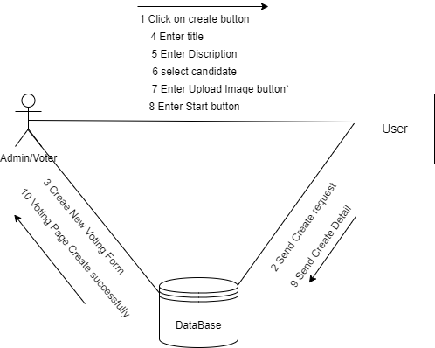

**Figure 5.10: Collaboration Create Voting Poll Diagram**

* + 1. **Collaboration Diagram 4; Cast vote**

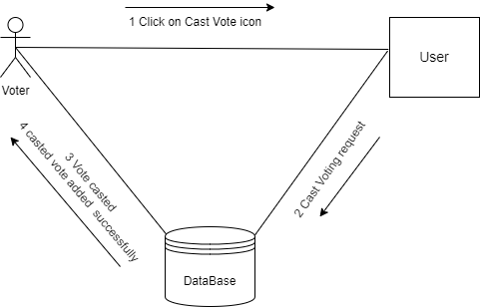

**Figure 5.11: Collaboration Cast Vote Diagram**

## ERD Diagram

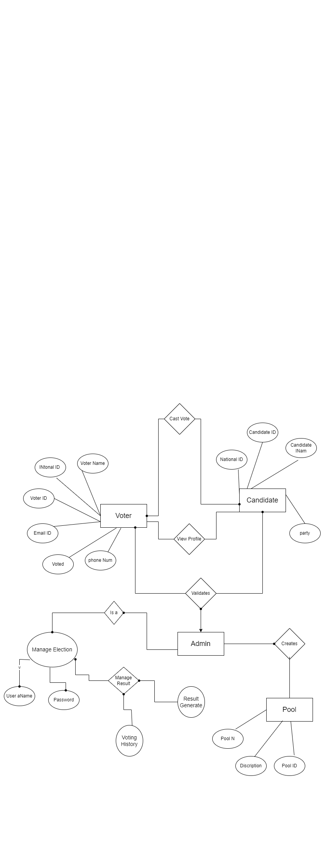

## Figure 5.12: Entity Relationship Diagram

# implementation Details

The implementation of an online voting platform Making Use of Face Recognition Using native programming languages, facial recognition technology facilitates the development of online applications. The frontend is created with a cutting-edge, intuitive user interface that adheres to platform-specific design standards. To exchange data, the application connects to a cloud server housed on a scalable platform or via a RESTful API.

* 1. **Development Setup**

The tool and software used in this project are listed below:

1. HTML
2. CSS
3. REACT
4. PHP
5. LARAVEL
6. JAVASCRIPT
7. BOOTSTRAP
8. DRAW.IO
9. MYSQL
   1. **Deployment Setup**

Our advisor and senior friesnds helped setup the development.There is an admin panel and uset interface. Admin can add, delete, update and edit voting process.During our implementation we made many mistake and face many hurdles whi;le working on this project, we face difficulty while implement the face recognition technology, then for come out of this problem we discuess it with my senior friend and advisor they teach us how to deployit using different technique, but its very helpful for our experience and also for in future work.

* 1. **Constraints**
     1. **Assumptions**
* It is assumed that necessary technical support can be provided by developers.
* The system authenticate the user information.
* The client can handle all database maintaince tasks,including backups, updates, and data integrity.
* There is no requirement for real time interfacing with any accounting systems, simplying the system architecture and integration requirement
* It is assumed that he user is aware of how to cast the vote.
  + 1. **Systeem Constraints**
* During peak voting times, the system needs to be able to accommodate a lot of concurrent users without seeing a drop in performance.
* The architecture of the system needs to be scalable in order to accommodate a growing number of voters over time.
* Only authenticate user can be able to cast the vote during voting process.
* The system must be highly reliable, with minimal downtime or service interruptions.
* Only admin can delete, update, create and edite the voting schedule.
* The system must comply with relevant laws and regulations governing elections, data privacy, and facial recognition technology.
  + 1. **Restrictions**
* Needs proper internet connection during voting process.
* The project must focus on a specific aspect or subset of online voting with face recognition to ensure that it is achievable within the specific timeframe and resources.
* User valid id card must required for cast vote.
* The project must comply with relevant lw and regulations including data protection, privacy, and electro process.
* User can not cast the vote after the voting time duration ended.
* The project must follow moral guidelines and precepts, particularly with regard to equity in the application of facial recognition technology.
* If the voter accidentally selects the incorrect candidate, they are unable to cast their vote again.
  + 1. **Limitations**
* Due to the constraints of student project, the developed system may have limitations in terms of scalability,robustness, and real world deployment compared tocommerical grade solutions.
* The system may not undergo extensive validation and testing process typically of producation grade software due to time and resource constraints.
* The project may not fully adhere to industry standards and nest practices in software engineering, given the educational context and focus on learning.

# Testing

The online voting system's trial phase Making Use of Face Recognition To guarantee that it satisfies the necessary standards of functionality, security, usability, and performance, face recognition is essential. When it comes to functional testing, we concentrate on confirming key features like voter registration, facial recognition, and the voting procedure. The system's accessibility and user interface are evaluated through usability testing. Testing for performance makes sure the system can withstand the highest load. The goal of security testing is to find and fix flaws that confidentiality and integrity of voter data. Feedback from representatives is gathered during user acceptability testing in order to improve the system and increase user happiness.

* 1. **Extended Use Cases**

**Table 7.1: Sign Up Extended Use case**

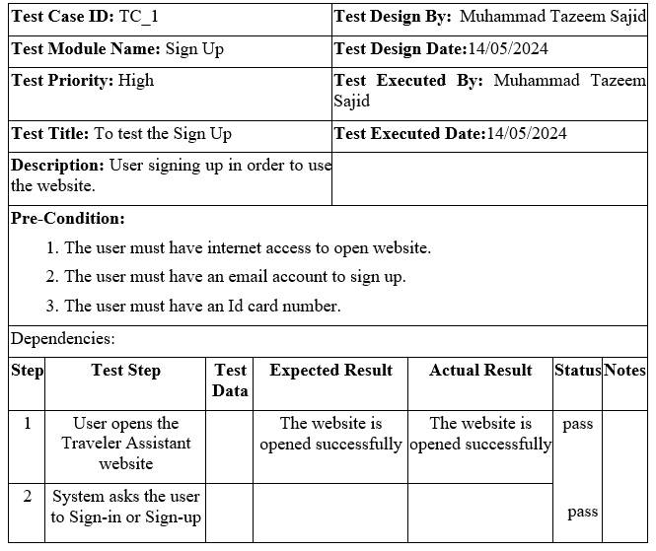

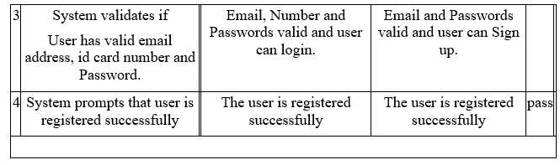

**Table 7.2: Sign_In Extended Use case**

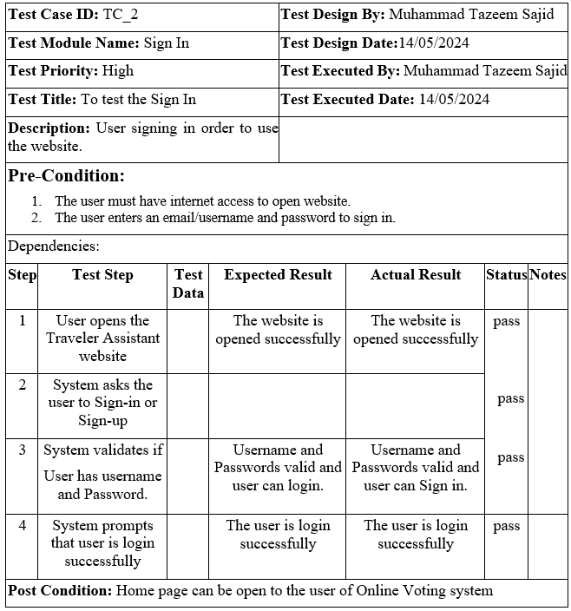

**Table 7.3: Admin Login Extended Use case**

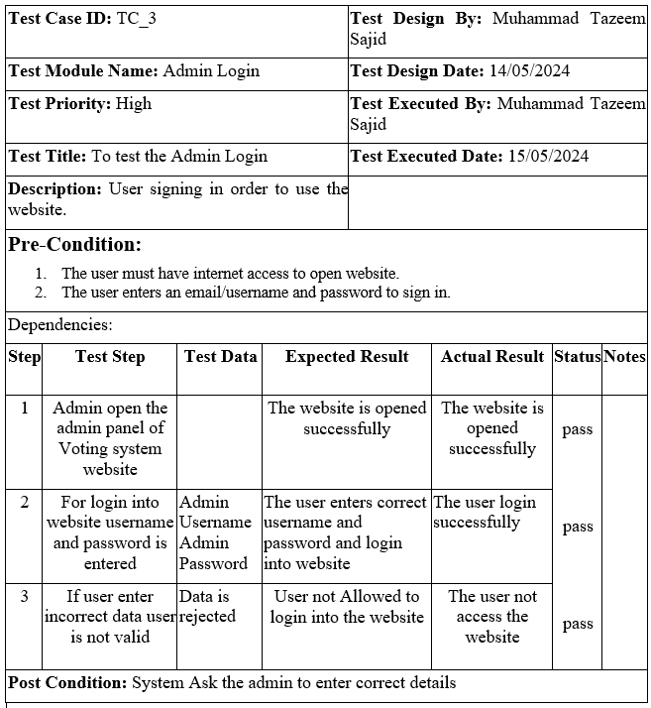

**Table 7.4: Create Pool Extended Use case**

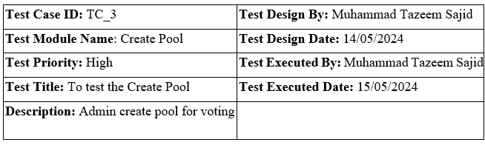

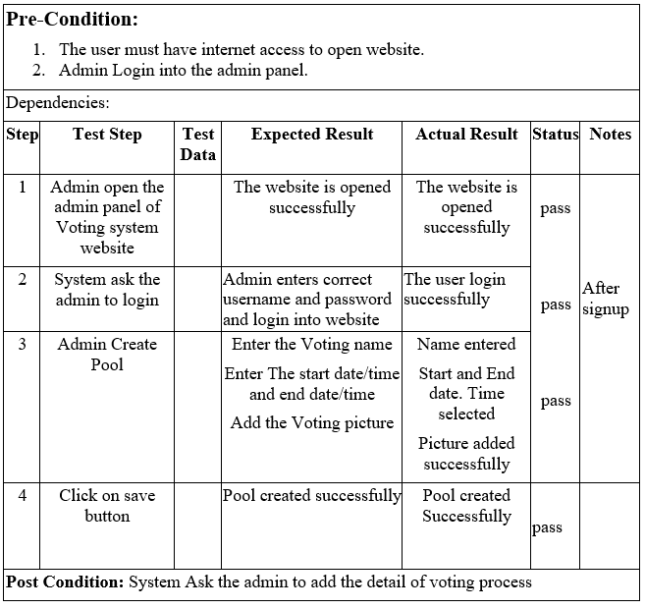

**Table 7.5: Delete Pool Extended Use case**

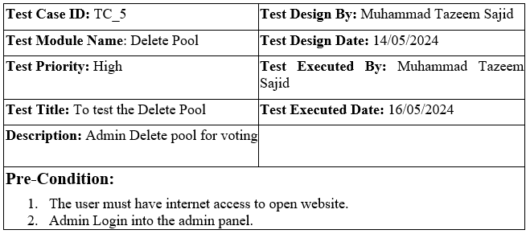

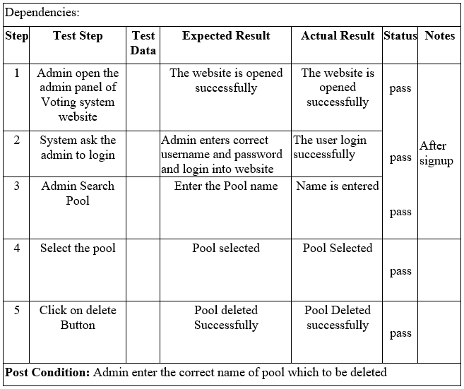

**Table 7.6: Update Pool Extended Use case**

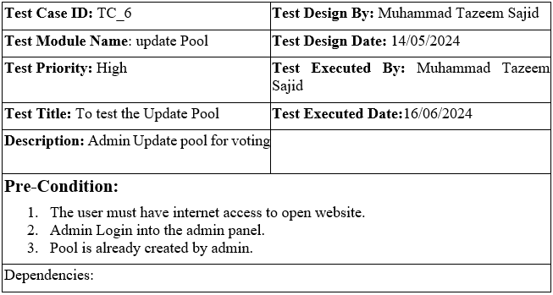

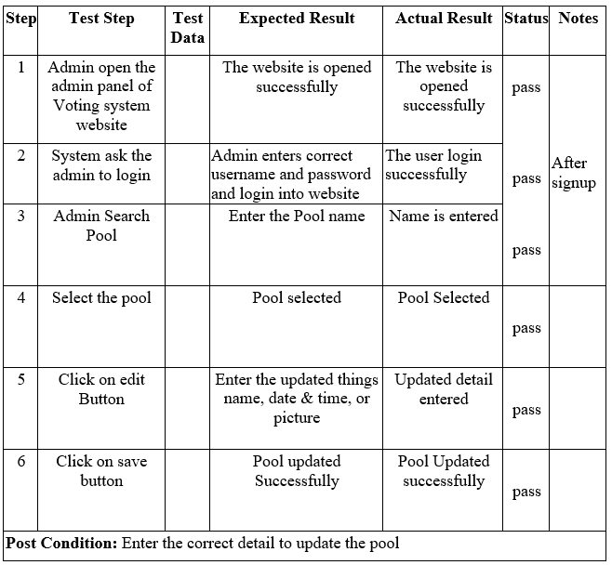

**Table 7.7: Cast Vote Extended Use Casen**

.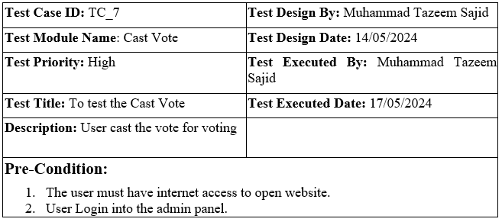

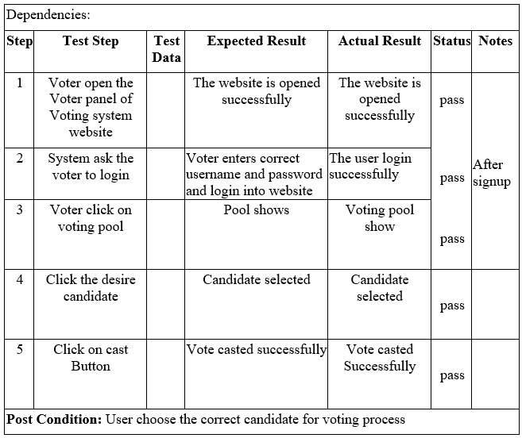

**Table 7.8: Generate Result Extended Use case**

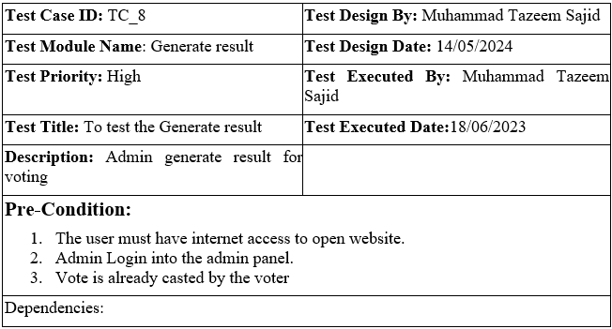

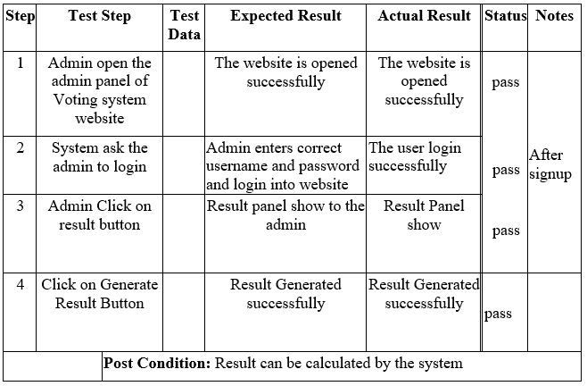

**Table 7.9: Feedback Extended Use case**

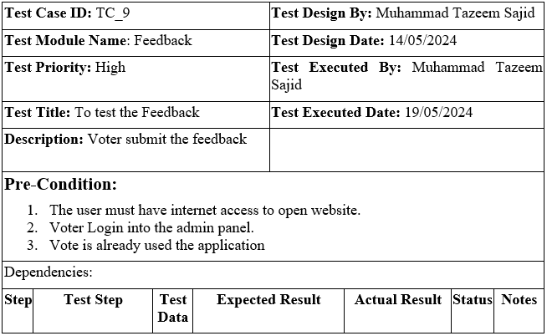

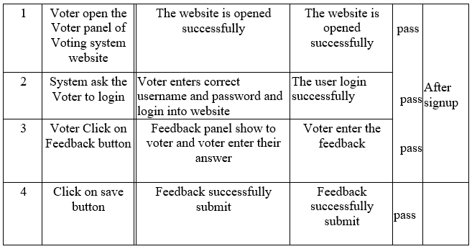

* 1. **Decision Table**

A decision table is a systematic and structured way of representing complex businessrules or condition along with their corresponding actions or outcomes. It provides a visual representation of all possible combination of conditions and teir resulting actions, making it easier to understand and manage complex decision making processes.Decision tables are particularly useful when dealing with multiple conditions that can result in different outcomes, as they help organize and clarify the logic behind decision-making prosesses. They are commonly used in various domains such as software development, business analysis, and process optimization

* + 1. **Code Snippet**

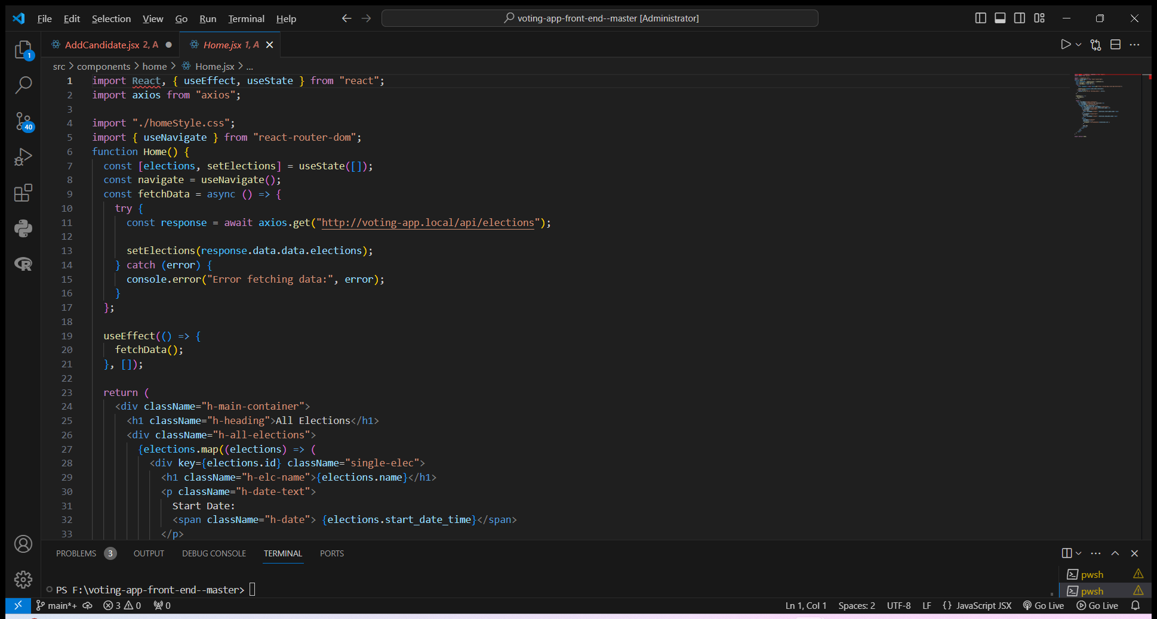

Figure 7.1: Home Screen Code

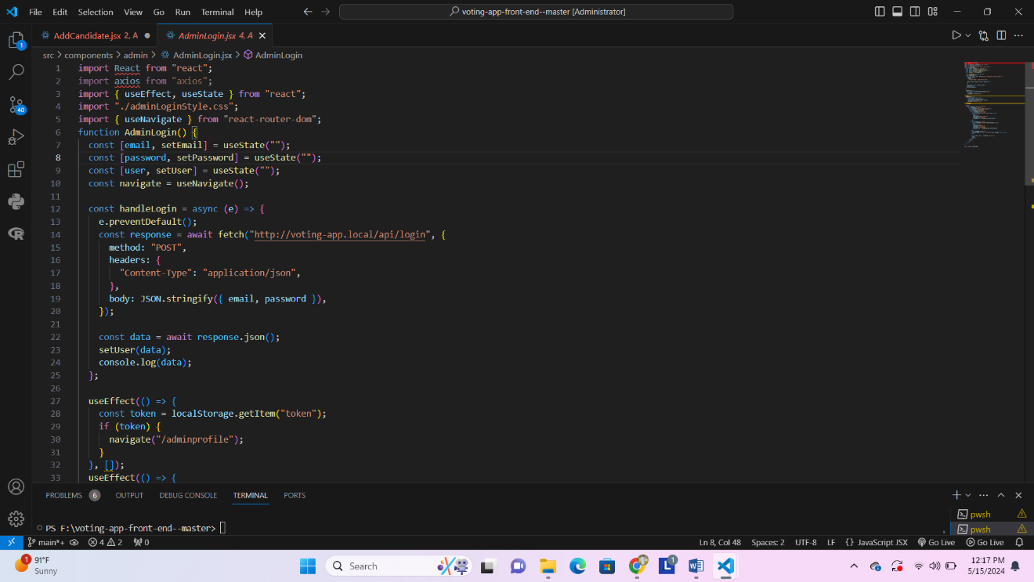

Figure 7.2: Login Screen Code

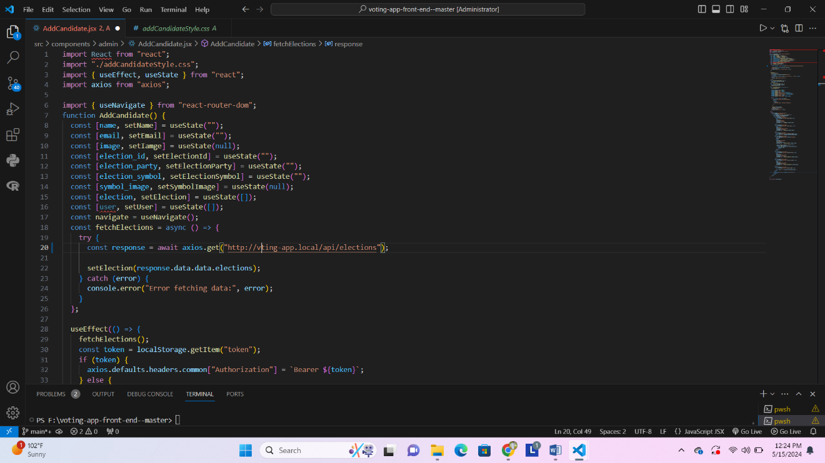

Figure 7.3: Add Candidate Screen Code

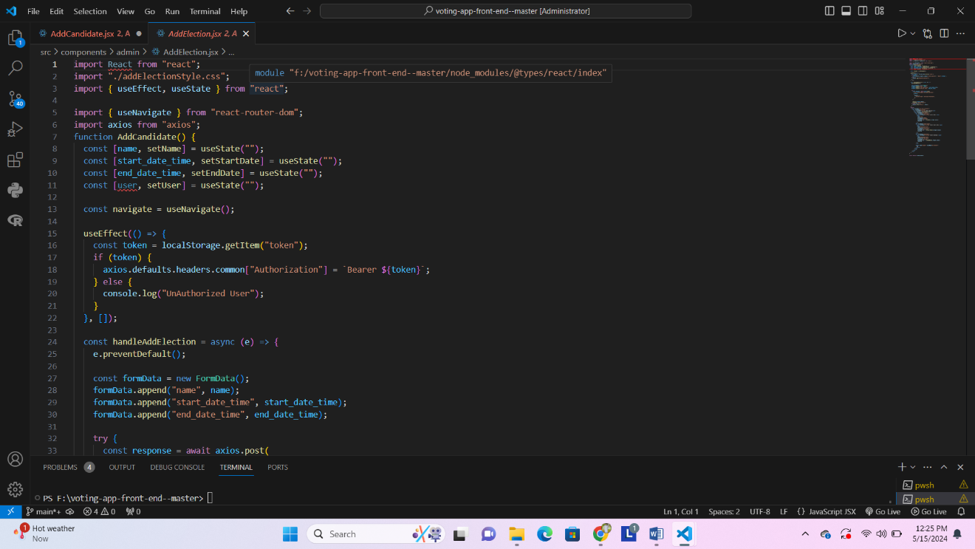

Figure 7.4: Add Election Screen Code

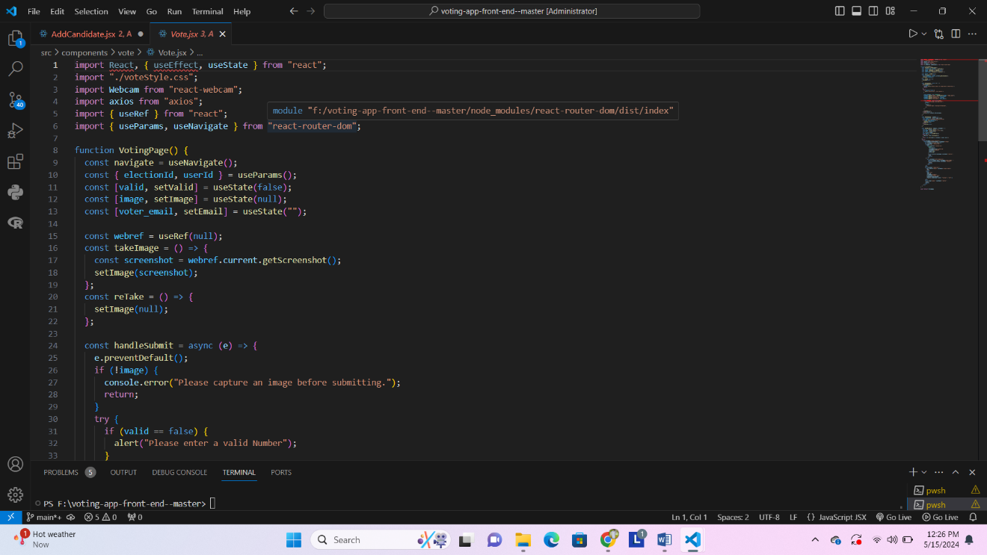

Figure 7.5: Voting Screen Code

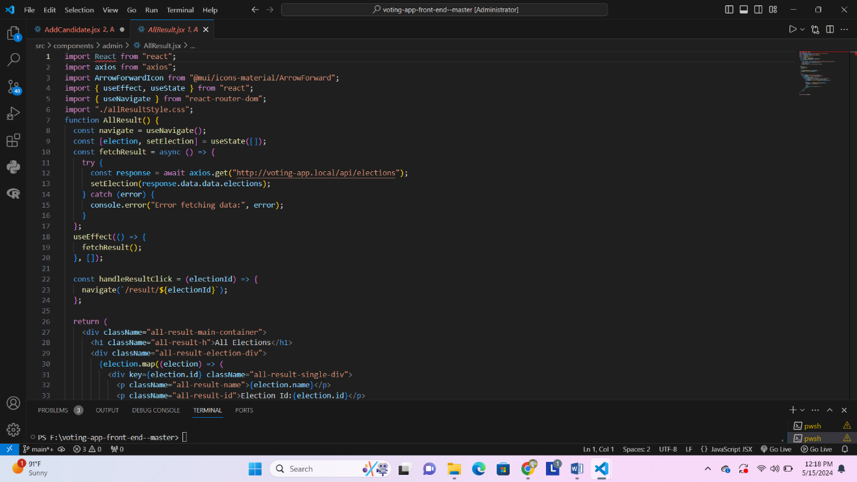

Figure 7.6: Result Screen Code

* 1. **Traceability Matrix**

Traceability matrix serves as a crucial tool in the development process of our online voting system using face recognition. It act as a bridge between various component of project including requirement, design emplement, test cases and delieverables, ensuring that every aspect of the projectis well-cordinated and alligned. By maping requirement to specific design elements and test cases, the traceability matrix enables us to face the origin and progress of each requirement throughout the project lifecycle.

### RID vs UCID (requirements vs use cases)

Table 7.10: RID vs UCID (requirements vs use cases)

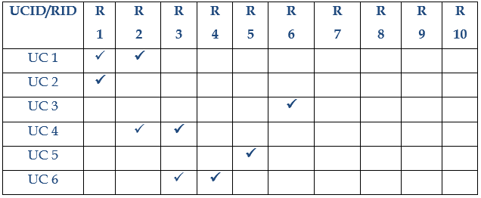

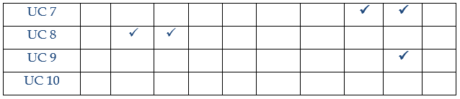

### Prototypes (RID vs PID)

Table 7.11: Prototype (RID vs PID)

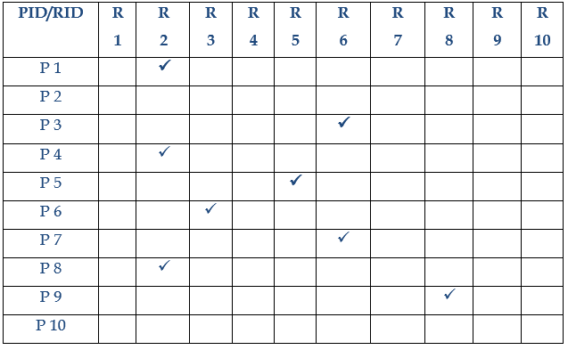

### Test Cases (RID vs TID)

Table 7.12: Test Cases (RID vs TID)

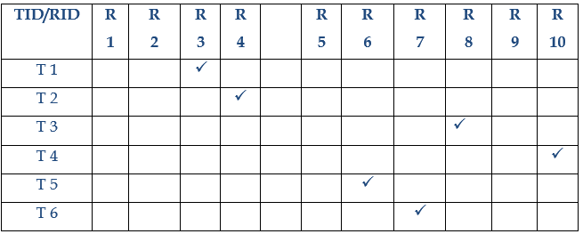

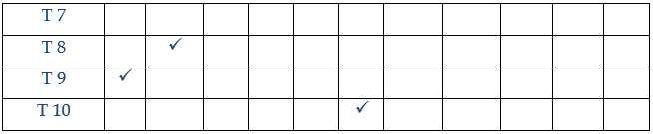

### Coverage (UCID vs TID)

Table 7.13: Coverage (UCID vs TID)

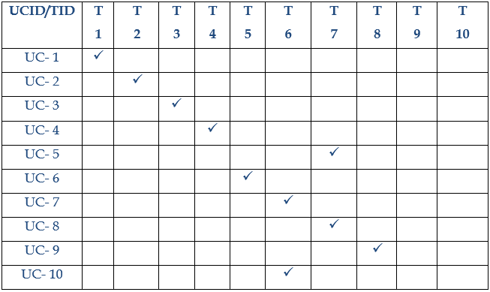

# Results/Output/Statistics

## Completion%

Fulfilled Requirements / Total Requirements * 100

|  |  |  |
| --- | --- | --- |
| **Total Number of Requirements Identified in RID** | **Number Of fulfilled requirements** | **Complexation Percentage** |
| 10 | 9 | 90% |

## %Accuracy

Correctly Implemented Requirement / Total Requirements * 100

|  |  |  |
| --- | --- | --- |
| **Total Number of Requirements Identified in RID** | **Number of Correctly Implemented Requirements** | **Accuracy Percentage** |
| 10 | 9 | 90% |

## %Correctness

Number of tested Requirements / Total Requirements * 100

|  |  |  |
| --- | --- | --- |
| **Total Number of Requirements Identified in RID** | **Number of tested Requirements Confirming to requirements** | **Correctness Percentage** |
| 10 | 9 | 90% |

# Conclusion

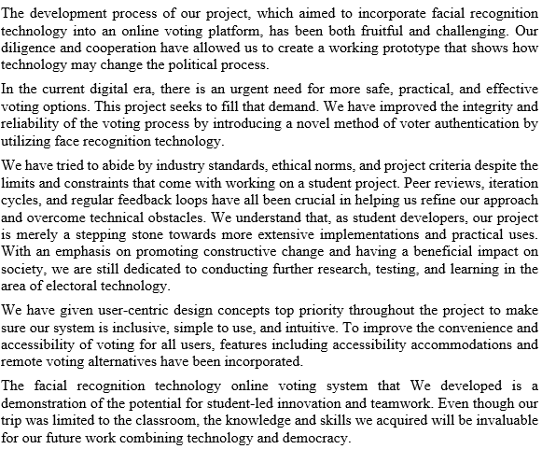

# Future work

As we move on with our student project on the online voting system with facial recognition, there are a few areas that are ready for investigation and improvement. First, we want build mobile application and foremost, we want to strengthen the system's security safeguards by putting in place then cutting-edge encryption strategies and biometric authentication systems to guard against potential identity theft and cyber-attacks. Further research into methods for improving resource usage and reaction times is necessary since maintaining the system's efficacy during large-scale elections also depends on its scalability and performance being optimized.

Furthermore, it is still critical to priorities usability and accessibility improvements in order to guarantee inclusivity for all users. This means that in order to expedite the voting process, user testing and feedback sessions must continue. Another path for future development is integration with the current government and electoral infrastructure, which makes data sharing and compliance with regulatory standards.

# Bibliography

[1] Aanjana Devi.S, Dr.Palanisamy.V and AnandhaJothi.R, “Confidential E-Voting

System Using Face Detection and Recognition”, Volume 3 Issue 4, July-Aug

2017, ISSN 2395-1303, pp 81-85.

[2] Swapnil Singh, Krunal Patil, Shaik Aftab, Kapil Chaudhary, Prof. Sushma A Shrike,

“Smart Voting System Using Face Recognition”, International Journal of Advanced

Research in Science, Communication and Technology (IJARSCT), Volume 2, May

2022, Page No: 52-57

[3] A. K. Kothawade, A. V. Bhopale, A. Y. S. Patil, P. Shewale, and D. Mahajan, “A

Novel Method of E-Voting System Using Biometrics Thumb Impression and Face

Recognition,” International Journal on Data Science and Machine Learning with

Applications, vol. 1, no. 1, May 2021, pp. 37–40.

[4] E. Fernando, D. Andwiyan, D. Fitria Murad, D. Touriano, and M. Irsan, “Face

recognition system using deep neural network with Convolutional Neural

Networks,” Journal of Physics: Conference Series, vol. 1235, no. 1, p. 012004,

2019. doi:10.1088/1742-6596/1235/1/012004.

[5] M S Sruthi and K Shanjai, “Retraction: Automatic voting system using Convolutional

Neural Network (J. Phys.: Conf. Ser. 1916 012074),” Journal of Physics:

Conference Series, vol.1916, no.1, p. 012314, 2021.

[6] Behrainwala, A. Saxena, A. Navlani, S. Sahay, N. Tarapore, “Smart voting

system using facial recognition,” International Journal for Research in Applied

Science and Engineering Technology, vol. 10, no. 1, pp. 308–313, 2022.

[7] K. H. S, B. G. B, H. M. P, A. D. L and A. V, "Secured And Transparent Voting

System Using BiometricAnd Face Recognition," 2021 International Conference on

Design Innovations for 3Cs Compute Communicate Control (ICDI3C), 2021, pp.

254-259.A.

[8] A. Mandavkar and R. V. Agawane, "Mobile based facial recognition using OTP

verification for voting system," 2015 IEEE International Advance Computing

Conference(IACC), 2015, pp. 644-649

# Appendix

